



April 21, 2026

Technical Bulletin:
i30 Data Label Correction

Issue:
In compliance with the EPA’s American Innovation and Manufacturing (AIM) Act of 2020, refrigerant gas used in the i30 has been changed from R404a to R290. This new R290 refrigerant was first used in i30 equipment manufactured in December of 2025.

Some of those units had the incorrect data label applied during production, which incorrectly stated the unit contained R404a refrigerant, and not the new R290 refrigerant. The labels also cited incorrect pressures for the refrigerant system.

This information is important, as R290 refrigerant is flammable, and any technician that is tasked with servicing a unit with R290 refrigerant must be aware of the flammable nature of the gas and be informed of the correct system pressures.

Solution:
The mislabeled equipment has been identified by serial number, and new data labels (included with this notice) with matching serial numbers have been produced.

Action:

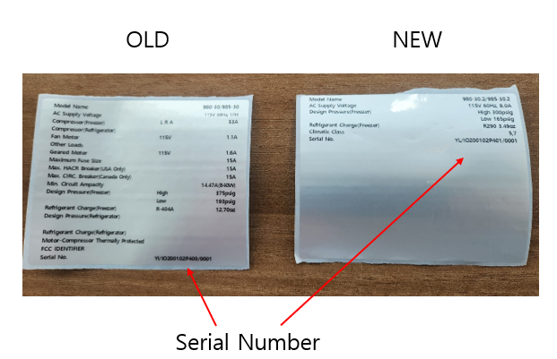
Customers receiving these corrected data labels are required to locate the affected units by serial number and apply the new data label over the existing data label (application detailed below). Customers are also required to photograph the application of the new data label and supply Wellsys with these photos.

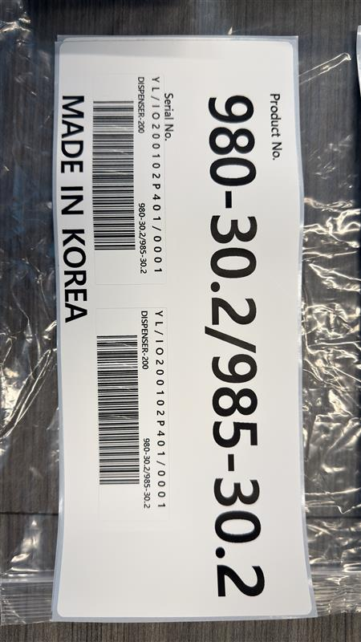
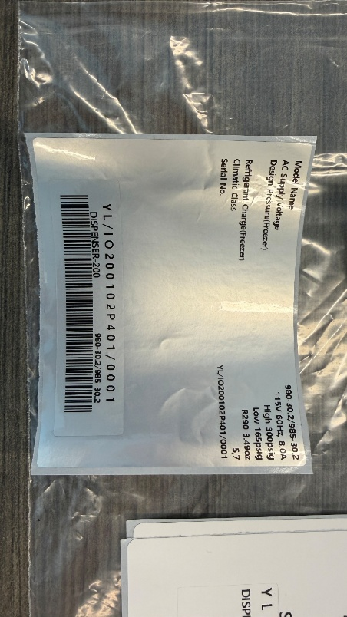

Label for Box
Label for Machine

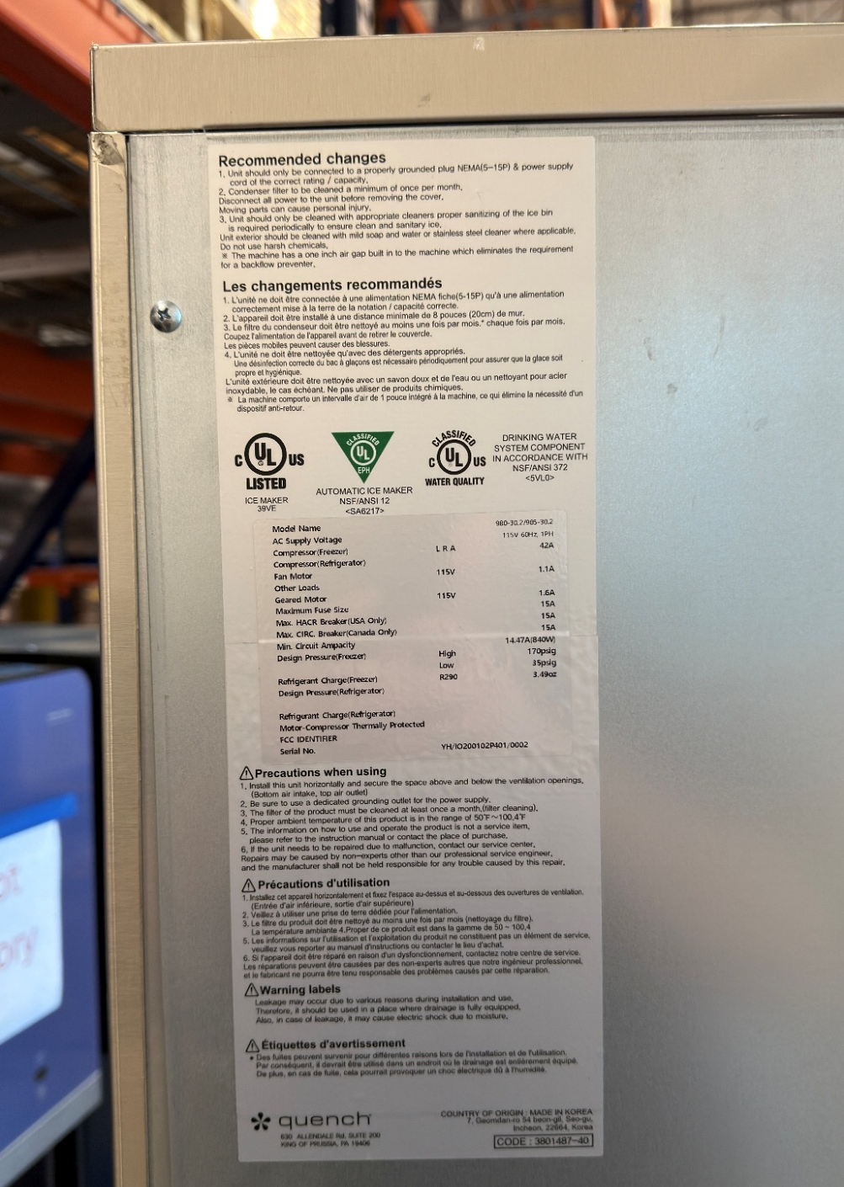
Location of Label on Machine

