



April 21, 2026

Technical Bulletin:
i30 Refrigerant Change Notice

Notice:
As of December 2025, all i30 equipment is now manufactured using R290 refrigerant gas, phasing out the previously used R404a. This change was made in accordance with the EPA’s American Innovation and Manufacturing (AIM) Act of 2020 which prohibits the use of certain high-GWP hydrofluorocarbons (HFCs) in specific products manufactured after January 1st, 2026. The Act sets a GWP (Global Warming Potential) limit of 150 or below which the R290 replacement meets with a GWP of three (3).

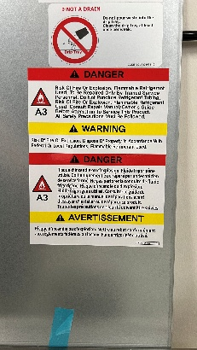
While R290 meets the new standard, it is a flammable gas, and as such requires related precautions when handling or servicing. R404a, the previously used refrigerant, is not flammable.

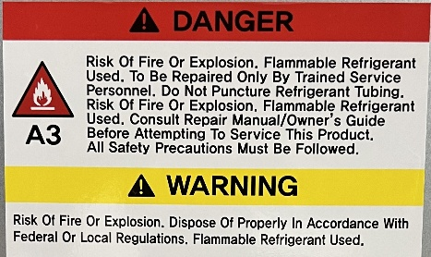
This notice is to inform all customers that have purchased the i30 of this change, and to make them aware that all i30 equipment manufactured since December of 2025 contains this new refrigerant and must be serviced accordingly.

Labeling Change:

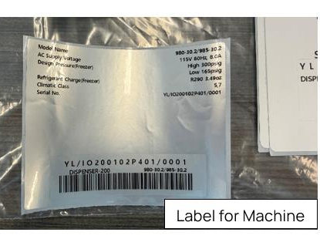
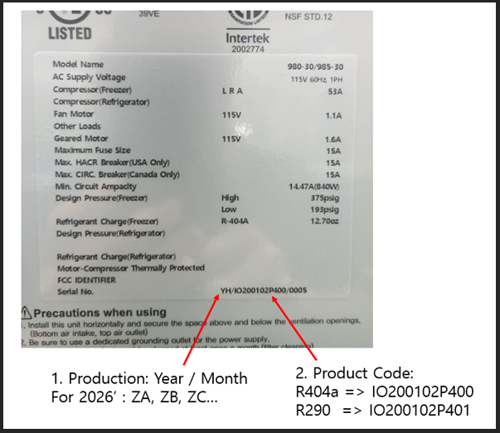
i30 units manufactured using R290 refrigerant have a change to the product code as well as additional warning labels on the back of unit meant to alert any service technician of the presence of R290 refrigerant.

